Reducing Refund-Related Support Tickets via an
AI Decisioning Layer
Case Study

Scope: AI-assisted auto-approval for low-risk, low-value product returns
Shopsy mid-size ecommerce platform

1. Business Overview & Problem Statement

1.1 Business Overview
Shopsy is a mid-size ecommerce platform operating across India, processing an average of 50,000 orders per day. Like most ecommerce businesses, Shopsy offers a 7-day return and exchange window on eligible products .

1.2 Business Problem Context
Every return request currently goes through a manual review process. A customer support agent reads the reason for return, checks the uploaded photo (if any), verifies the order details, and then approves or rejects the request. This applies uniformly whether the item is a ₹200 t-shirt with a minor size issue or a ₹15,000 laptop with a suspected fraud pattern.
Every return request currently follows a manual-first path. A customer support agent:
- Reads the stated reason for return
- Reviews uploaded photos (if any)
- Verifies order details and customer history
- Makes an approve/reject decision
- Triggers the refund manually

This process is applied uniformly a ₹200 t-shirt with a size issue receives the same level of scrutiny as a ₹15,000 laptop reported as "item not received."
As order volume grows ~15% year-over-year, this model is not scaling:
- Refund turnaround time averages 3–5 days, driving customer dissatisfaction and repeat "where is my refund?" contacts.
- Agents spend disproportionate time on low-risk, low-value cases that could be auto-resolved.
- Decision consistency varies between agents similar cases are sometimes approved and sometimes rejected, creating fairness and compliance concerns.
- High-risk and high-value cases don't receive deeper scrutiny because attention is spread evenly rather than risk-weighted.
- Support cost per refund is rising without a corresponding improvement in decision quality.

1.3 Problem Statement
How might Shopsy introduce an AI decisioning layer that automatically approves low-risk, low-value return requests instantly reducing refund related support ticket volume by an estimated 40% while routing high-risk or high-value cases to human agents for review, without increasing fraud exposure?

1.4 Why Now
- Return volume is growing faster than support headcount can scale
- AI classification models are mature enough for policy-bound decisions
- Customer expectations for instant resolution are rising
- Fraud patterns are becoming more sophisticated, requiring consistent rule application

2. Stakeholder Analysis
Understanding who is affected by and who influences this process is essential before defining requirements. The table below identifies key stakeholders, their interest in the initiative, and their level of influence.

Stakeholder | Role / Interest | Influence | Key Concern
Customer Support Head | Owns support SLAs and agent workload | High | Reducing manual review volume without hurting resolution quality
Finance / Risk Team | Owns fraud loss and refund cost | High | Auto-approval must not increase refund fraud or abuse
Product / Engineering | Builds and maintains the AI classification logic | High | Feasibility, data availability, and system integration
Customer Support Agents | Handle escalated / flagged cases | Medium | Trust in AI decisions; clear escalation path for edge cases
Customers | Requesters of refunds/exchanges | Medium | Fast, fair, and transparent resolution
Warehouse / Logistics | Processes physical returns | Low | Return pickup and inspection still needs to happen for exchanges
Compliance / Legal | Ensures policy adherence | Low | Refund policy consistency and audit trail

3. Business Requirements: Objective, Scope & Assumptions

3.1 Business Objective
Reduce average refund turnaround time and manual review workload for low-risk return requests by introducing an AI-assisted auto-approval layer, while maintaining or improving fraud detection for high-risk cases.

3.2 Business Rules
- Auto-approval is only applicable to return requests where order value is below a defined threshold (e.g., ≤ ₹1,000).
- Auto-approval is only applicable to a defined set of "common" return reasons (e.g., wrong size, minor defect, changed mind) not reasons associated with higher fraud risk (e.g., "item not received", "item damaged in transit" for high-value electronics).
- A customer's return/refund history is checked and the first time or low frequency requesters are eligible for auto approval, customers with unusually high return frequency are excluded and routed to manual review.
- All auto approved decisions are logged and a random sample is periodically audited by the Risk team.

3.3 Scope & Assumptions

In Scope
- Return requests for physical product defects, wrong item, and size/fit issues
- Auto-approval and auto-rejection logic for low-value, low-risk requests
- Routing of high-value or high-risk requests to human agents
- Refund initiation trigger once a request is approved (auto or manual)
- Basic reporting/dashboard on auto-approval rate, turnaround time, and override rate

Out of Scope
- Exchange logistics (pickup scheduling, courier assignment) assumed to use existing systems
- International/cross-border returns
- Refund payment processing mechanics (assumed handled by existing payment gateway integration)
- Full fraud investigation workflow for flagged cases only the routing/flagging is in scope

Assumptions
- Historical return data (reason codes, approval outcomes, fraud flags) is available and reasonably clean for model training.
- Customers upload at least one photo when reporting a damaged/wrong item.
- The existing order management system can expose order value, order history, and customer return history via API.
- Legal/compliance has no objection to automated decision-making for refunds under the defined threshold.

Business Requirements
BR-ID | Business Rule | Requirement | Priority | Raised by
BR-01 | Value Threshold | Auto-approval shall only apply to return requests where the order value is ≤ ₹1,000. Requests above this threshold shall route to manual review. | High | Finance / Risk Team
BR-02 | Reason Eligibility | Auto-approval shall only apply to requests with defined "common" return reasons: Wrong size, Minor defect, Changed mind, Wrong item shipped. Requests with reasons "Item not received", "Item damaged in transit" (electronics/high-value), or "Item not as described" (high-value categories) shall always route to manual review. | High | Customer Support Head
BR-03 | Customer History Check | Customers with unusually high return frequency (>3 returns in 90 days OR return rate >40%) shall be excluded from auto-approval and routed to manual review. | High | Finance / Risk Team
BR-04 | First-Time Returner Eligibility | First-time and low-frequency returners shall be eligible for auto-approval, provided all other business rules are satisfied. | Medium | Customer Support Head
BR-05 | Confidence Threshold | Only requests scored at ≥95% confidence by the classification engine shall be auto-approved. Requests scoring below this threshold shall route to manual review, regardless of value or reason. | High | Product / Engineering
BR-06 | Audit Sampling | All auto-approved decisions shall be logged. A random 5% sample shall be audited weekly by the Risk team. | High | Compliance / Legal
BR-07 | Fail-Safe Default | If the classification service is unavailable, requests shall default to manual review. The system shall never auto-approve on service failure. | High | Product / Engineering
BR-08 | Per-Customer Cap | No more than 3 auto-approved refunds shall be permitted per customer per 30-day window. Requests beyond this cap shall route to manual review. | High | Finance / Risk Team

4. Process Flow: As-Is vs To-Be

4.1 As-Is (Current State)
Every return request regardless of value or risk follows the same manual path:
- Customer submits a return/refund request with a reason and optional photo.
- Request enters a shared support queue.
- Support agent picks up the request, manually reviews order details, reason, and photo.
- Agent makes an approve/reject decision (average time: 3–5 days due to queue backlog).
- If approved, the refund is triggered manually and the customer is notified of the approval; if rejected, the customer is notified with the reason.

Key bottleneck: Steps 3–4 form a single, undifferentiated queue a ₹150 t-shirt return and a ₹20,000 laptop "item not received" claim receive the same level of manual attention, with no risk-based prioritization.

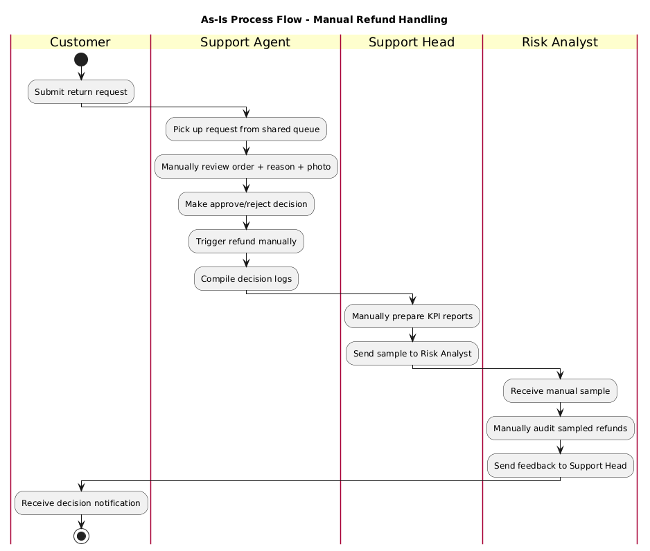

4.2 To-Be (Proposed State)
The proposed flow inserts an AI classification step immediately after request submission:
- Customer submits a return/refund request with a reason and optional photo (unchanged).
- AI classification engine evaluates the request against business rules: order value, return reason category, and customer return history.
- Requests are classified into one of three outcomes:
  - Auto-approve : low-risk, low-value requests with ≥95% confidence; refund is triggered automatically and the customer is notified.
  - Auto-reject : requests clearly outside policy (e.g., beyond 7-day window); customer is notified with reason and given an appeal option.
  - Manual review : high-risk, high-value, or low-confidence requests; routed to the agent queue.
- Manual-review requests are flagged with the AI's reasoning (e.g., "high return frequency", "high order value", "confidence below threshold") to speed up agent review.
- Agent reviews flagged cases with AI-provided context, approves/rejects as today.
- All auto-approved and auto-rejected decisions are logged for periodic audit sampling by the Risk team.
- Agent overrides are captured with reasons and fed back into the model retraining pipeline.

Fail-safe: If the AI classification service is unavailable, requests default to manual review the system never auto-approves on failure.

Impact: The support queue now contains only genuinely ambiguous or risky cases, and agents review those with more context than they had before reducing ticket volume by ~40% while maintaining (or improving) fraud detection.
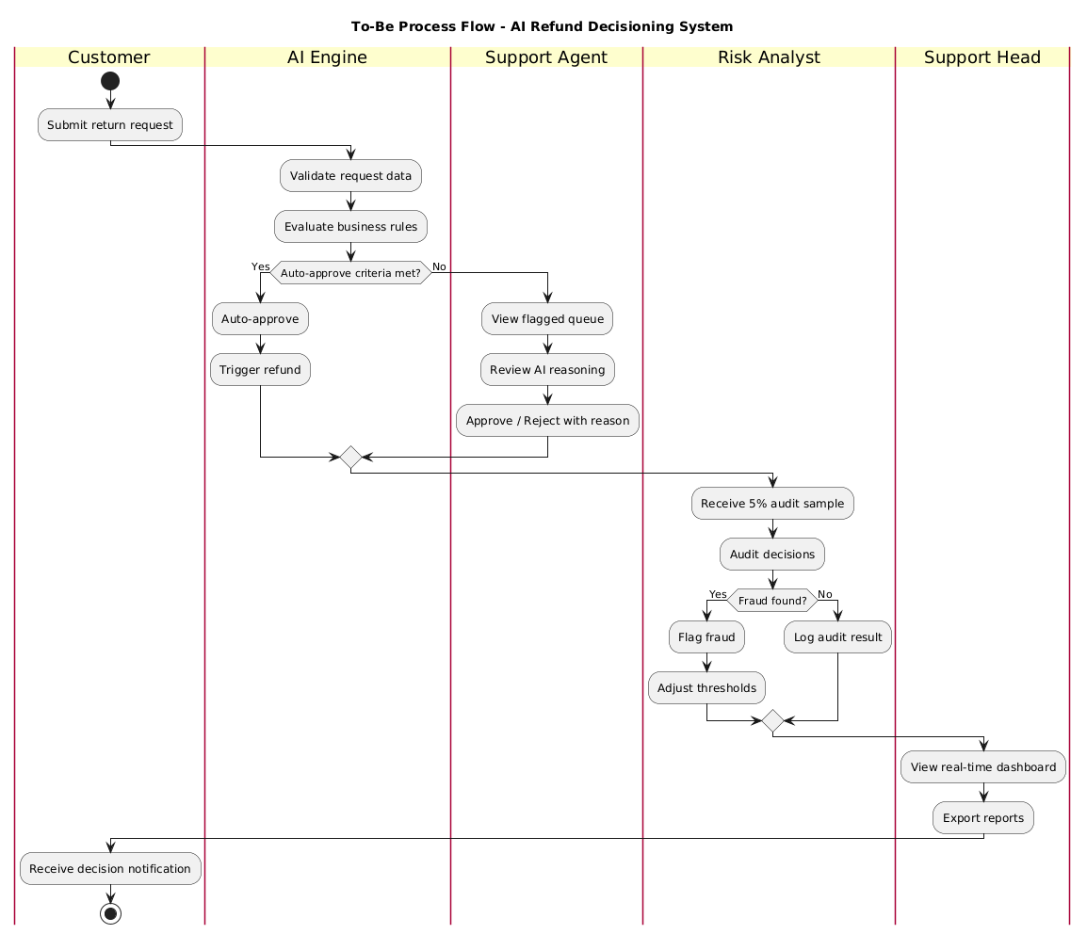

4.3 Process Comparison
Dimension | As-Is | To-Be
Decision path | Single manual queue | AI triage → auto or manual
TAT (low-risk) | 3 – 5 days | < 5 minutes
TAT (high-risk) | 3 – 5 days | < 24 hours
Decision consistency | Agent dependent | Rule-based, auditable
Agent context | Manual lookup | AI reasoning pre-attached
Fraud detection | Ad hoc | Rule-based + confidence threshold
Audit trail | Partial | Rule-based + confidence threshold

5. Use Case Flow

Use Case: Auto-Evaluate Return Request
Field | Description
Use Case ID | UC-01
Actor(s) | Customer (initiator), AI Classification Engine, Support Agent (for flagged cases)
Precondition | Customer has an eligible order within the 7-day return window
Trigger | Customer submits a return/refund request
Main Flow | 1. Customer selects order and reason, uploads photo. 2. System captures order value and pulls customer return history. 3. AI engine scores the request against business rules. 4. If score falls within auto-approve criteria → system approves and triggers refund. 5. If not → system creates a flagged ticket in agent queue with AI reasoning attached.
Alternate Flow | If required data (e.g., photo) is missing for a reason type that needs it, request is held and customer is prompted to provide it before scoring.
Postcondition | Request is either auto-approved (refund initiated) or routed to an agent with contextual flags
Exceptions | AI engine or dependent service is unavailable → request defaults to manual queue (fail-safe, not fail-open)

6. Functional & Non-Functional Requirements

6.1 Functional Requirements
ID | Requirement | Priority | Raised by
FR-01 | System shall capture return reason, order value, and customer return history at the time of request submission. | Must | Customer Support Head
FR-02 | System shall classify each return request as "auto-approve", "auto-reject", or "manual review" based on defined business rules. | Must | Product / Engineering
FR-03 | System shall automatically trigger a refund for requests classified as "auto-approve", without agent involvement. | Must | Customer Support Head
FR-04 | System shall route "manual review" requests to the agent queue along with the AI's classification reasoning. | Must | Customer Support Agents
FR-05 | System shall log every auto-approved and auto-rejected decision with the reasoning, for audit purposes. | Must | Compliance / Legal
FR-06 | System shall notify the customer of the decision (approved / rejected / under review) within 5 minutes of submission. | Must | Customer Experience (CX)
FR-07 | System shall allow the Risk team to adjust auto-approval thresholds (order value, reason categories) without engineering changes. | Must | Finance / Risk Team
FR-08 | System shall display the AI's flag reason(s) on every manually routed ticket | Must | Customer Support Agents
FR-09 | System shall capture agent override reasons with mandatory selection | Must | Product / Engineering
FR-10 | System shall cap auto-approved refunds per customer per 30-day window | Should | Finance / Risk Team
FR-11 | System shall generate a randomized audit sample of auto-approved decisions on demand | Should | Finance / Risk Team
FR-12 | System shall provide a reporting dashboard with auto-approval rate, TAT, override rate, and fraud rate | Should | Customer Support Head
FR-13 | System shall feed agent override data into a model retraining pipeline | Could | Data / ML Team
FR-14 | System shall support A/B testing of different threshold configurations | Could | Product / Engineering

6.2 Non-Functional Requirements

ID | Requirement | Priority | Raised by
NFR-01 | Classification decision shall be returned within 3 seconds of request submission (to support a near-instant customer experience). | Must | Product / Engineering
NFR-02 | System shall handle peak load of 5,000 return requests/hour during sale periods without degraded response time. | Must | Product / Engineering
NFR-03 | Auto-approval logic shall be auditable — every decision must be traceable to the specific rule/score that triggered it. | Must | Compliance / Legal
NFR-04 | System shall maintain 99.5% uptime for the classification service; on failure, requests default to manual review (fail-safe). | Must | Product / Engineering
NFR-05 | Customer and order data used in classification shall be handled per existing data privacy and security policy. | Must | Compliance / Legal
NFR-06 | The classification engine shall only auto-approve requests above a defined confidence threshold (e.g., ≥ 95% confidence); requests scoring below this threshold shall be routed to manual review regardless of value or reason. | Must | Finance / Risk Team
NFR-07 | The confidence threshold shall be tunable by the Risk team based on the observed cost of a false approval (a genuinely fraudulent/invalid claim that gets auto-approved) versus the cost of an unnecessary escalation (a valid claim sent to manual review). | Must | Finance / Risk Team
NFR-08 | PII shall be encrypted at rest and in transit. | Must | Compliance / Legal
NFR-09 | Audit logs shall be retained for 7 years. | Must | Compliance / Legal
NFR-10 | Human override shall always be available on any decision. | Must | Customer Support Agents
NFR-11 | System shall support 500 concurrent classification requests. | Should | Product / Engineering
NFR-12 | Model drift shall be monitored with alerts when distribution shifts >10% | Should | Data / ML Team

Note on thresholds: a lower confidence threshold increases auto-approval rate (and ticket reduction) but raises the risk of false approvals; a higher threshold is safer but reduces the automation benefit. This trade-off is revisited in Section 12.1.

7.User Stories & Acceptance Criteria

Use Case Flow

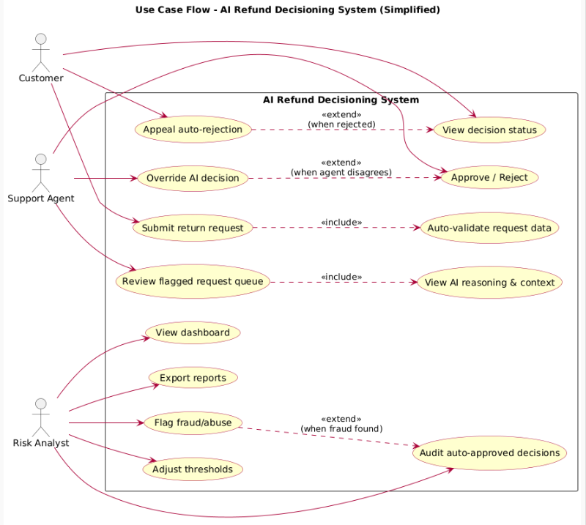

8.UI/UX Requirements and Screen Layout

Customer-Facing: Return Request Screen

Key elements required on this screen:

Order selector (dropdown of eligible orders within return window)

Return reason selector (predefined categories: wrong size, defective, wrong item, changed mind, item not as described, other)

Photo upload field (required for defect/wrong-item reasons)

Refund vs. exchange toggle

Submit button, followed by an instant status message: "Approved — refund initiated" / "Under review — we'll update you within 24 hours"

8.2 Agent-Facing: Flagged Request Queue

Key elements required on this screen:

Queue list sorted by flag priority (e.g., high order value first)

Per-request panel showing: order details, customer return history summary, uploaded photo, and the AI's flag reason(s)

Approve / Reject action buttons with a mandatory reason/comment field

Link to view the customer's full return history for context

Screen 1: Support Agent — Flagged Refund Request Screen
Layout:

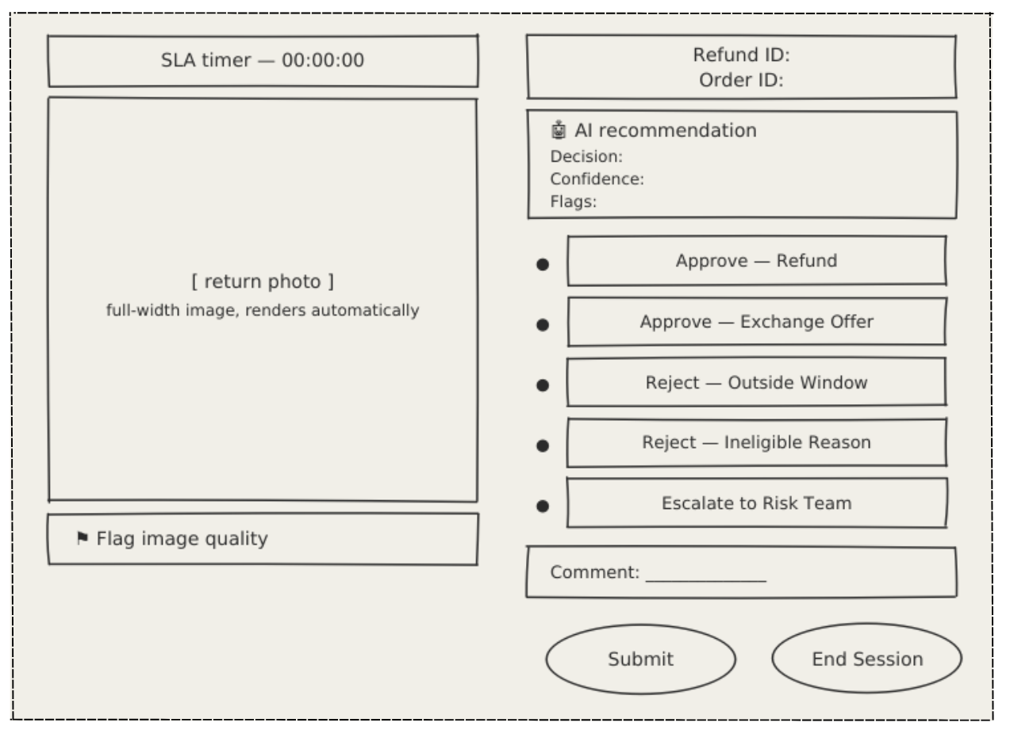

Specifications:
- Return photo displayed full-width within the left panel
- Image renders automatically, no link to open
- Image cannot be zoomed or manipulated — zooming leads to inconsistent decisions and increases TAT
- AI recommendation panel is always visible above decision options
- Decision options are radio buttons — only one selection allowed
- Submit button enabled only after a decision is selected
- Rejection and escalation require a mandatory comment
- Flagging opens a confirmation modal
- After submission, next flagged request loads automatically

Screen 2: Customer — Return Request Screen
Layout:

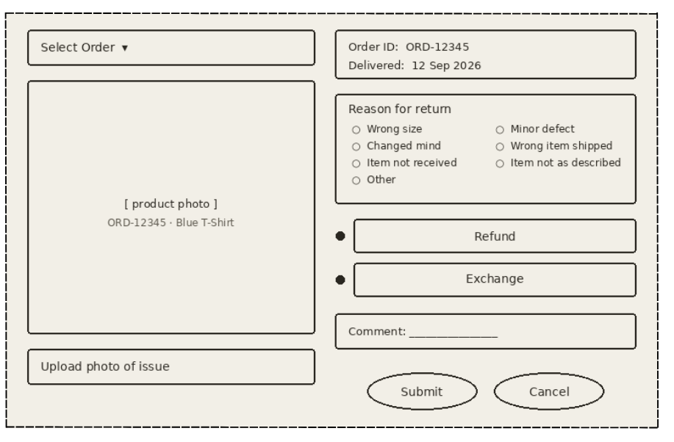

Specifications:
- Order dropdown shows only orders within the 7-day return window
- Photo upload required only for "Minor defect" and "Wrong item shipped"
- Resolution defaults to "Refund"
- Submit button disabled until required fields are filled
- On submission, screen transitions to Decision Status within 3 seconds

Screen 3: Customer — Decision Status Screen
Layout:

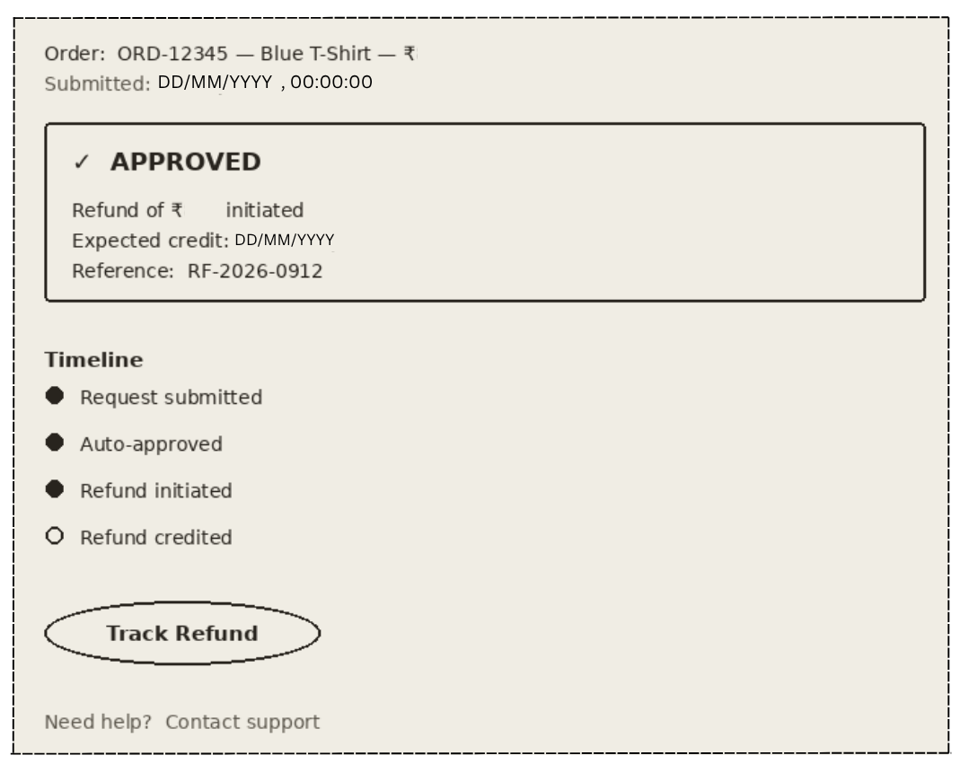

Specifications:
- Three possible states: Approved / Under Review / Rejected
- Refund reference auto-generated and shown prominently
- Timeline read-only; updates automatically
- Appeal option visible only on Rejected state
- Expected credit date calculated from refund initiation date

Screen 4: Risk Analyst — Audit Dashboard
Layout:

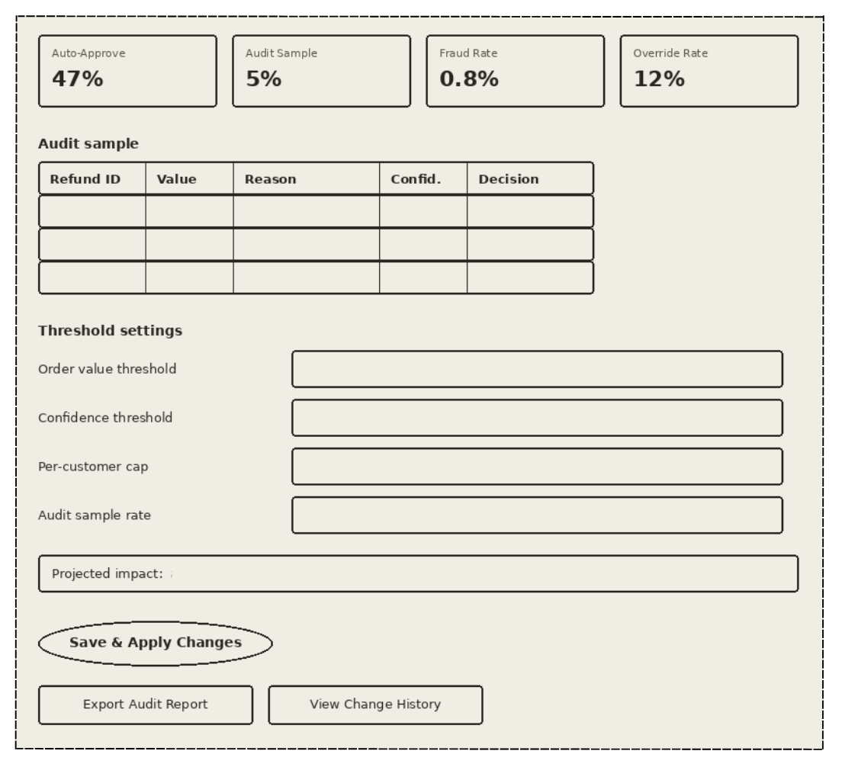

Specifications:
- KPI cards refresh every 15 minutes
- Audit sample randomized weekly; filterable by reason, value band, date
- Threshold changes require a mandatory approver comment
- All threshold changes logged with name, timestamp, previous value
- Projected impact recalculates live as analyst adjusts sliders
- Export options: CSV, PDF — includes full reasoning log per decision

Screen 5: Support Head — Real-Time Dashboard
Layout:

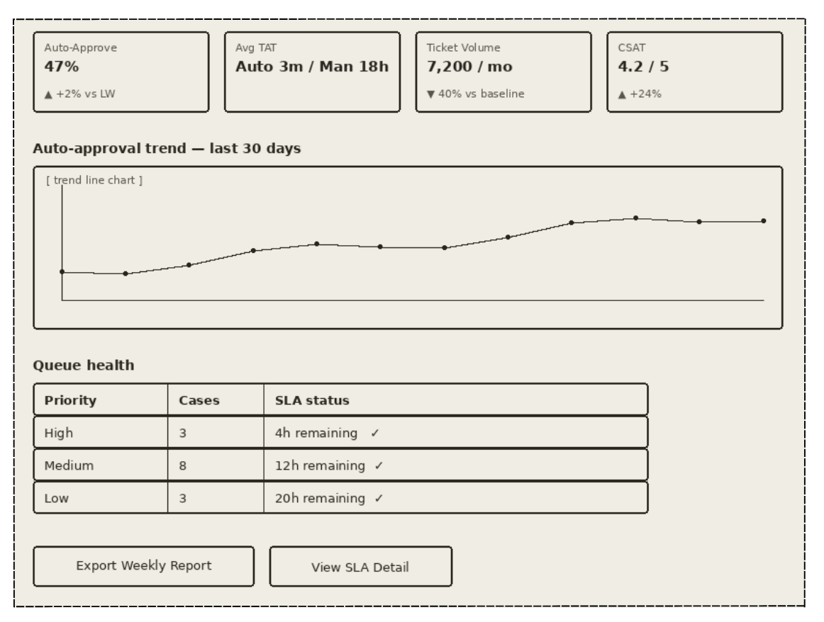

Specifications:
- Metrics refresh every 5 minutes
- Trend chart supports drill-down by reason, segment, region
- Queue Health cards turn amber at 50% SLA elapsed, red at 80%
- Export options: PDF, Excel
- Access controlled by role Support Head and above only

Screen 6: Session Summary (Support Agent — End of Session)
Layout:

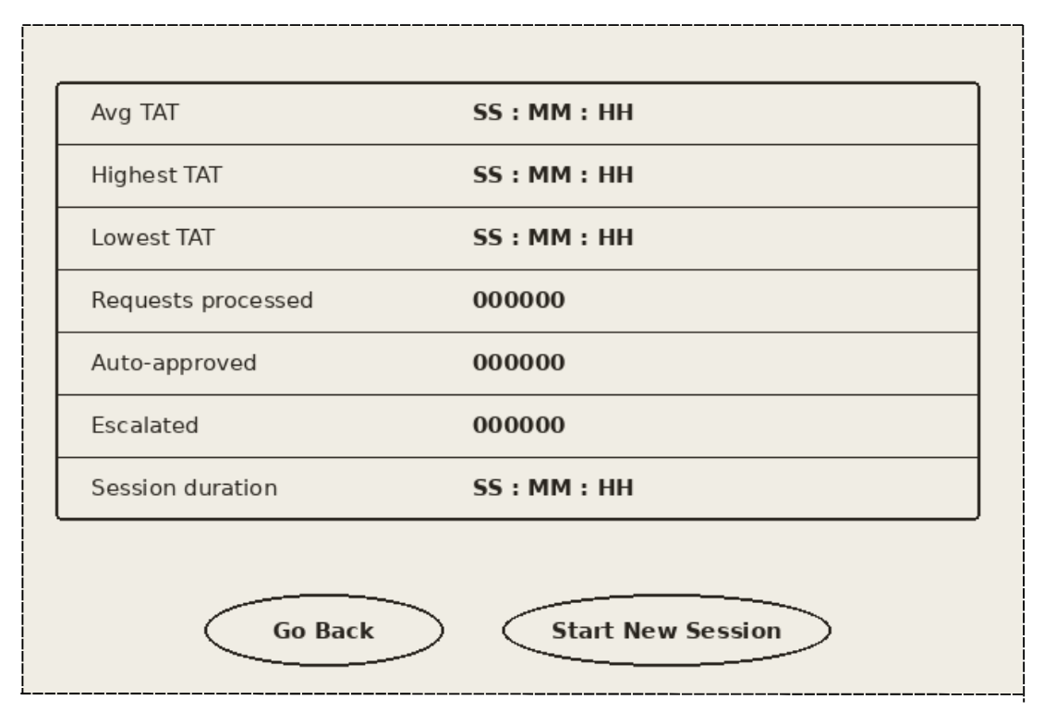

Specifications:
- Displayed automatically when agent ends a session
- Session history accessible from the agent's profile
- If no requests processed, display "No activity in the session"
- Go Back leads to main page of tool
- Start New Session resets queue and starts fresh SLA timer

8.3 Layout Notes
Screen layouts are described at a conceptual/wireframe level here rather than as pixel-precise mockups, consistent with the depth expected of a BA-authored requirements document (detailed UI design would typically be owned by a UX designer working from these requirements).

9. UAT & Testing
9.1 UAT Approach
User Acceptance Testing will validate that the classification engine and routing logic behave as defined in the business rules, from both customer experience and support agent workflow perspectives. Testing will use a mix of historical (replayed) return requests and newly simulated edge cases.

Test types:

Functional: rule logic, routing, notifications

Decision accuracy: precision/recall against historical labeled data

Edge cases: missing data, service failures, cap breaches

Override flows: agent override, reason capture, feedback loop

Reporting: dashboard accuracy, audit sampling

Performance: response time under load

Environment: Staging with masked production-like data

Duration: 2 weeks

9.2 UAT Entry Criteria

Functional and non-functional requirements signed off by Business and Product

Classification engine deployed to staging with representative historical data

Test cases and expected outcomes documented and reviewed

UAT testers trained (Support Agents, Risk Analyst)

Defect severity definitions agreed

Rollback plan documented

9.3 UAT Exit Criteria

All critical and high-priority test cases pass

≥95% pass rate on Must-have requirements

Zero open Sev-1 or Sev-2 defects

No open defects causing incorrect auto-approval on high-risk requests

All Sev-3 defects have agreed workarounds or deferral sign-off

Business and Risk stakeholders formally sign off on go-live readiness

Rollback plan validated

9.4 UAT Test Cases

TC - ID | High Level Scenario | Expected Outcome | Tester  Role | Priority
TC-01 | Low-value order (≤ ₹1,000), common reason (wrong size), first-time returner submits request | Request is auto-approved instantly; refund initiated within 5 minutes; customer notified | Support Agent | Critical
TC-02 | High-value electronics order, reason "item not received" submitted | Routed to manual review with flags "high order value" + "risk-sensitive reason"; agent sees AI reasoning | Support Agent | Critical
TC-03 | Low-value order, but customer has >3 returns in 90 days | Routed to manual review with "frequent returner" flag; agent sees return history summary | Support Agent | Critical
TC-04 | Defect reason submitted without required photo upload | Request is held; customer prompted to upload photo before scoring; no decision made | Support Agent | High
TC-05 | Classification service is down/unavailable during submission | Request defaults to manual review queue (fail-safe); on-call alert triggered | Product / Engineering | Critical
TC-06 | Agent overrides an AI-flagged "manual review" decision | Override and mandatory reason captured in audit log; feedback sent to model pipeline | Support Agent | High
TC-07 | Order is outside 7-day return window | Auto-rejected with clear reason "outside return window"; customer given appeal option | Support Agent | Critical
TC-08 | Customer submits 4th auto-approval-eligible request in 30 days | Routed to manual review with "auto-approval cap reached" flag | Support Agent | High
TC-09 | Request scores 92% confidence (below 95% threshold) despite low value and common reason | Routed to manual review despite meeting value + reason criteria | Support Agent | Critical
TC-10 | Risk team requests weekly audit sample of auto-approved decisions | Randomized 5% sample returned with full reasoning logs; traceable to specific rules | Risk Analyst | High
TC-11 | Risk analyst updates value threshold via admin console | New rules active within 5 minutes; change logged with approver name, timestamp, previous value | Risk Analyst | High
TC-12 | Peak load simulation: 5,000 requests/hour | No degradation; p95 response time < 3 seconds; no failed classifications | Product / Engineering | Critical
TC-13 | Submit requests containing PII | Data encrypted at rest/transit; no PII appears in logs or notifications | Compliance / Legal | Critical

10. KPI Definitions & Reporting Requirements
10.1 KPI Definitions

KPI | Definition
Auto-Approval Rate | % of total return requests resolved via auto-approval (no agent involvement)
Average Refund Turnaround Time | Average time from request submission to refund initiation, split by auto-approved vs. manually reviewed
Agent Override Rate | % of AI-flagged "manual review" cases where the agent's decision differs from what the AI would have defaulted to
Fraud/Abuse Rate (Auto-Approved) | % of auto-approved requests later identified as fraudulent or abusive during audit sampling
Support Ticket Reduction | % reduction in return-related tickets requiring agent handling, compared to pre-automation baseline (target: 40%)
Model Confidence Distribution | Distribution of classification confidence scores across requests — used to tune the auto-approval threshold and monitor drift over time
Customer Satisfaction (Returns) | CSAT score specifically for the return/refund experience, pre- vs. post-automation

10.2 Reporting Requirements
- A daily operational dashboard showing auto-approval rate, turnaround time, and queue volume for the Support Head.
- A weekly audit report for the Risk/Finance team showing a random sample of auto-approved decisions and any confirmed fraud/abuse cases.
- A monthly trend report tracking support workload reduction and CSAT impact, for leadership review.

11.Expected Business Impact & Recommendations
11.1 Expected Business Impact
Metric | Success Metric | As - Is | To - Be
Auto-Approval Rate | ≥ 45% of total return volume | 0% — every request routed to manual review | 40–50% of low-risk, low-value requests auto-approved instantly
Refund TAT (Low-Risk) | Reduce from days to under 5 minutes | 3–5 days due to queue backlog and manual review | Under 5 minutes for auto-approved cases
Refund TAT (Manual Review) | Reduce by 70%+ | 3–5 days with no prioritization by risk | Under 24 hours with AI-context-prioritized queue
Support Ticket Reduction | 40% reduction in return-related tickets | ~12,000 return tickets/month requiring agent handling | ~7,200 tickets/month— 40% reduction
Agent Throughput | 2X increase in cases handled per agent per day | ~80–100 return cases/agent/day (mixed complexity) | ~160–200 cases/day — agents focus only on flagged/ambiguous cases
Cost Per Refund | Reduce by 50% | ₹500 per refund (agent time + processing) | ₹250 per refund — automation reduces manual handling cost
Decision Consistency | ≥ 98% consistency across similar cases | ~85–90% — varies between agents, no standardized criteria | ≥ 98% — rule-based, auditable, same inputs produce same outputs
Fraud/Abuse Rate (Auto-Approved) | Maintain at or below baseline | Baseline fraud rate under manual review | ≤ Baseline — enforced via confidence threshold + per-customer cap
False-Approval Rate | < 1% of auto-approved decisions | N/A -no automation today | < 1% — validated through weekly audit sampling
Audit Coverage | ≥ 5% random sampling, configurable | Ad hoc, inconsistent, no structured sampling | 5% automated random sample, configurable by Risk team
Feedback Loop Speed | Immediate within minutes | Days manual relay between agents and Risk team | Immediate agent overrides feed model retraining pipeline in real time
Real-Time Reporting | Near real-time dashboards | Manual report consolidation, weekly/monthly | Real-time dashboards auto-approval rate, TAT, override rate, fraud rate
Refund CSAT | Improve by 10+ points | driven by slow resolution and uncertainty | driven by instant approvals and clear communication
Repeat Purchase Rate (Refunded Customers) | Improve by 8% | Baseline refund experience negatively impacts retention | +8% faster, fairer resolution improves trust and repeat purchase
SLA Compliance | ≥ 99% of requests resolved within defined SLA | No formal SLA enforcement; TAT varies widely | ≥ 99% auto-approved < 5 min,manual review < 24 hrs
Monthly Cost Savings | Quantified savings | - | ~₹3 lakh/month from reduced agent workload
Annualized Savings | Full-year impact | - | ~₹36 lakh/year + retention uplift

11.2 Recommendations
- Build it in phases (sprint by sprint):
Sprint 1 – Core AI engine + auto-approval + refund trigger
Sprint 2 – Agent screen + flagged queue + AI reason display + override option
Sprint 3 – Audit sampling + Risk dashboard + threshold settings
Sprint 4 – Reports + role-based access + export
Sprint 5 – Testing + bug fixes + go-live prep
Sprint 6 – Go live + support
- Launch with a conservative auto-approval threshold (e.g., ≤ ₹500) and a narrow set of return reasons, then expand gradually as confidence in the model grows.
- Run the AI classification in "shadow mode" first logging what it would decide without actually auto-approving to validate accuracy against historical agent decisions before going live.
- Establish a monthly review cadence between Risk, Support, and Product teams to revisit thresholds based on audit findings.
- Extend this same classification approach later to the exchange workflow, once refund automation is validated.
12. Risks, Dependencies & Known Gaps
12.1 Risks

Risk | Mitigation
Customers learn the auto-approval pattern and exploit it (e.g., repeated low-value fraudulent claims) | Cap auto-approvals per customer per time period; flag unusual frequency for manual review
Model makes a systematically biased decision (e.g., unfairly rejecting a valid category) | Shadow-mode testing before go-live; periodic audit sampling with clear escalation path
Over-reliance on AI reduces agents' domain expertise over time | Keep a rotating sample of auto-approved cases visible to agents for periodic review, not just audit
False approvals (cost of wrongly auto-approving an invalid/fraudulent claim) outweigh the savings from ticket reduction | Set the confidence threshold conservatively at launch (favoring escalation over auto-approval); calculate the ₹ cost of a false approval vs. the ₹ cost of an agent-hour, and tune the threshold to the point where expected savings are maximized
Threshold tuned too conservatively, limiting the 40% ticket-reduction target | Use shadow-mode data to plot the precision/recall trade-off at different thresholds before committing to a launch threshold

12.2 Dependencies
- Order Management System must expose order value and order history via API.
- Customer return history data must be accessible and reasonably complete.
- Risk/Finance team availability to define initial thresholds and conduct audit sampling.

12.3 Known Gaps
- This case study does not cover the exchange logistics workflow (pickup, courier assignment) assumed unchanged.
- International returns and cross-border refund rules are not addressed. Model training data quality/availability is assumed rather than validated against a real dataset, since this is a portfolio case study rather than a live implementation.

13. Approval & Revision History
13.1 Approval
Name | Role | Decision | Date
[Stakeholder Name] | Customer Support Head | Approved | [Date]
[Stakeholder Name] | Finance / Risk Lead | Approved | [Date]
[Stakeholder Name] | Product Owner | Approved | [Date]

13.2 Revision History
Version | Date | Author | Change Description
0.1 | [Date] | [Your Name] | Initial draft - business problem, stakeholder analysis
0.2 | [Date] | [Your Name] | Added requirements, process flows, and use case
1.0 | [Date] | [Your Name] | Final version - added UAT, KPIs, risks, and recommendations

